PIZZA SALES SQL QUERIES AND RESULTS
- KPI’S
- TOTAL REVENUE:
SELECT SUM(total_price) FROM pizza_sales
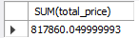

- AVERAGE ORDER VALUE
Select SUM(total_price)/ count(distinct order_id) AS avg_order_value From pizza_sales;
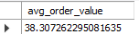

- TOTAL PIZZAS SOLD
SELECT SUM(quantity) AS total_pizza_sold FROM pizza_sales;
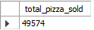

- TOTAL ORDERS
SELECT COUNT(DISTINCT order_id) AS total_orders FROM pizza_sales;


- AVERAGE PIZZAS PER ORDER
SELECT SUM(quantity)/COUNT(DISTINCT order_id) AS avg_pizza_per_order FROM pizza_sales;
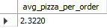

- CHARTS REQUIREMENTS
- DAILY TREND FOR TOTAL ORDER

SELECT
DAYNAME(STR_TO_DATE(order_date, '%d-%m-%Y')) AS day_of_week,
COUNT(DISTINCT order_id) AS total_orders
FROM
pizza_sales
WHERE
order_date IS NOT NULL
GROUP BY
day_of_week
ORDER BY
FIELD(day_of_week, 'Monday', 'Tuesday', 'Wednesday', 'Thursday', 'Friday', 'Saturday', 'Sunday');
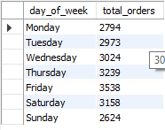

- MONTHLY TREND FOR TOTAL ORDERS

SELECT monthname(STR_TO_DATE(order_date, '%d-%m-%Y')) AS Month_of_year, COUNT(DISTINCT order_id) AS total_orders FROM pizza_sales
WHERE order_date IS NOT NULL
GROUP BY Month_of_year
ORDER BY FIELD(Month_of_year, 'January', 'February', 'March', 'April', 'May', 'June', 'July', 'August', 'September', 'October', 'November', 'December');
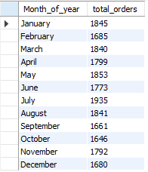

- PERCENTAGE OF SALES BY PIZZA CATEGORY

SELECT pizza_category, SUM(total_price) * 100/ (SELECT sum(total_price) FROM pizza_sales) FROM pizza_sales
GROUP BY pizza_category;
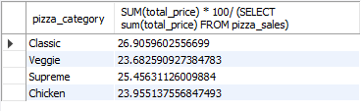

- PERCENTAGE OF SALES BY PIZZA SIZE

SELECT pizza_size, SUM(total_price) * 100/ (SELECT sum(total_price) FROM pizza_sales) FROM pizza_sales
GROUP BY pizza_size;

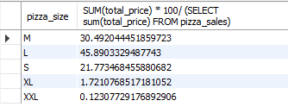

- TOTAL PIZZAS SOLD BY PIZZA CATEGORY

SELECT pizza_category, SUM(quantity) FROM pizza_sales
GROUP BY pizza_category;
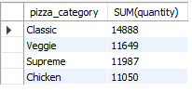

- TOP 5 BESTSELLERS BY REVENUE, TOTAL QUANTITY AND TOTAL ORDERS

SELECT pizza_name, SUM(total_price), SUM(quantity), COUNT(DISTINCT order_id) FROM pizza_sales
GROUP BY pizza_name
ORDER BY SUM(total_price) desc, SUM(quantity) desc, COUNT(DISTINCT order_id) desc
LIMIT 5;
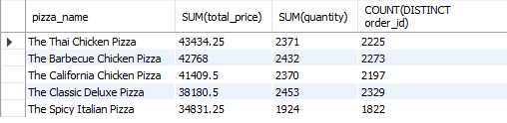

- BOTTOM 5 WORST SELLERS BY REVENUE, TOTAL QUANTITY AND TOTAL ORDERS

SELECT pizza_name, SUM(total_price), SUM(quantity), COUNT(DISTINCT order_id) FROM pizza_sales
GROUP BY pizza_name
ORDER BY SUM(total_price), SUM(quantity), COUNT(DISTINCT order_id)
LIMIT 5;
